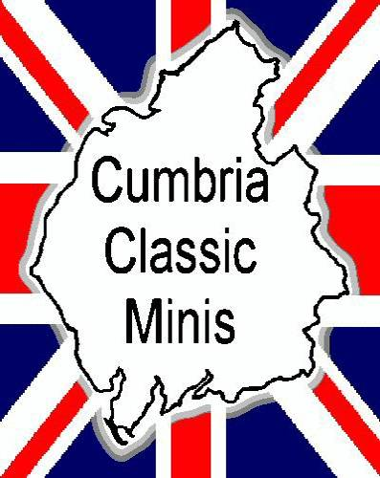
Mini 1959 – 2000

Accept No Imitations!

Are you interested in Mini's? If so we would like to bring our club to your attention

Based in North Eastern Cumbria, but with members all over the county, we are a small, friendly club.
As a member of our club you can take advantage of discounted insurance, access to a large spares database, plus free or reduced entry to shows.
Club membership also entitles you to substantial discounts at selected outlets both local and national.
Join fellow Mini enthusiasts on trips to shows, treasure hunts, track days, and take part in Mini only tours. Come along to our meetings for a good natter, and catch up on all the local Mini related news.

From Original to outright Monster, from the mobile Shed to the spec'd up trophy winner, the Cumbria Classic Mini Club has something for you.

Want to Join?

For more information contact Richard Allen on 01768 862412 or 01768 866749 after 6pm on weekdays, fill out the form overleaf, or email us at
admin@cumbriaclassicminis.co.uk

P.T.O

Membership Application Form
Membership:- Single £5 Family, (two minis) £8 per annum

About You

Mr / Mrs / Miss
First Name:
Surname:
Address:

Postcode:
Telephone No.: Mobile No:
Date of Birth:
Occupation:

About your Mini
Registration:
Model and Year:
Modifications and/or Interesting Info

Do you want an Internal or External club windscreen sticker?

Do You own a computer? Yes / No

Do You have access to the internet? Yes / No

Your E-mail address.

Club Use
Mem No. CCMC Renewal Date
Please forward to Richard Allen, `Aldersyde', 25 Graham Street, Penrith, Cumbria. CA11 9LG
Cheques payable to: Border City Mini Club

Mini Thanks

